English 9 – Ms. Kamrass – Weekly Sheet
Quarter 2 – Week 2

November is a time to.

A Day B Day
Monday, 11/18 Goal –read nonfiction to better understand origins of the Holocaust

- Quiz Groups 13-15
- SSR
- “Overview of Anti-Judaism and Antisemitism”

Homework: Complete the Article of the Month in Google Classroom.

Tuesday, 11/19 Goal – read nonfiction to better understand origins of the Holocaust  - SSR  - “Overview of Anti-Judaism and Antisemitism”  Homework: ENSURE THAT ENTIRE PACK IS COMPLETE WHEN YOU ARRIVE FRIDAY (EXCEPT “Who is Responsible for this Inhumanity?”). Complete Identity Poster and have it with you when you arrive for Night in a Day. Directions for making it are on the last page of your Night in a Day pack. | Wednesday, 11/20 Goal –read and examine the exposition  - Read chapter 1 of Night  - Night in a Day is Friday  Homework: ENSURE THAT ENTIRE PACK IS COMPLETE WHEN YOU ARRIVE FRIDAY (EXCEPT “Who is Responsible for this Inhumanity?”). Complete Identity Poster and have it with you when you arrive for Night in a Day. Directions for making it are on the last page of your Night in a Day pack. *You also need to bring you copy of the book and the card with the child’s name.
Thursday, 11/21 Goal – learn about people, prejudice, and the Holocaust through fiction and nonfiction.  - Read chapter 1 of Night  - Night in a Day is tomorrow  Homework: Complete 1. The Night pack (except for the “Who is Responsible…” section) and 2. your Identity Poster. Have everything with when you arrive for Night in a Day. Directions for making it are on the last page of your Night in a Day pack.  *You also need to bring you copy of the book and the card with the child’s name. | Friday, 11/22  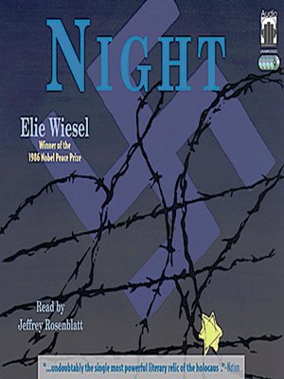  Night in a Day  All 9th Graders will be in this day-long assembly  *Please bring your Night Packs and Identity Posters with you.

